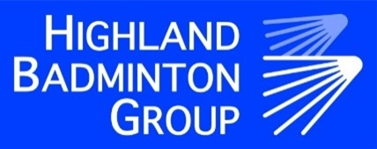
Register of Interest for HBG Inter Area Team 2022/23

We intend to enter a team into the Inter Area Team competition which will be held later in the year (Date still to be confirmed).
From the Highland Junior Restricted competition, the top 4 boys and girls (with the highest combined score from their best 2 events) will be automatically selected for the team.
Any remaining places will be allocated to players from their position in Badminton Scotland’s ranking list (these will be filtered for age groups).
Players are awarded points based on their final position in the draw at the Highland Junior Restricted held on June 4th in Inverness Leisure Centre.
Winner: 50pts
Runner-up :40pts
3rd Place :30pts
4th Place :20pts
Quarter finals: 10pts
Last 16: 5pts

Any player wishing to be considered for team selection must complete and return the following form to HBGentries@gmail.com or send to Maressa Munro, Feorlig House, Dunvegan Isle of Skye IV55 8ZL by 18th June 2022.

Players Name
Address
Date of Birth
Member No.
Email Address
Telephone No.

Parents Name:

Parents Signature:

Date:

